# **Subject line:**

# Intro

Welcome back to SOCHI News! Hopefully midterms are (or almost) over, and you can finally escape the Ugli before 1am. And since you’ve got time…we’ve got a ton of upcoming events for you to look forward to! Today also marks the 30th anniversary of WikiWikiWeb, the grandfather of Wikipedia. Fun fact: the founder chose the word “wiki”, meaning “quick” in Hawaiian, to reflect the speed of editing a page on WikiWikiWeb. Visit the first user-edited website [here](https://wiki.c2.com/?WikiWikiWeb).

# Upcoming Events



FLUX, SIMA, and SOCHI are teaming up to bring you CONVERGE—the first-ever designathon at UMSI, happening on April 12, 2025! Get ready for an exhilarating one-day competition where you can participate solo or with a team to craft a portfolio-ready solution and pitch it to a panel of industry-leading judges for a chance to win exciting prizes. The official sign-up form drops on April 1st—stay tuned, and we’ll see you there!

[POSTER]

Expand your UX toolkit with a focused session on designing for accessibility. Join us on **Friday April 4th, 2pm** as we dive into essential practices like color contrast, structure, target spacing, and accessible text and work on creating accessibility-compliant UI components. Stay tuned for room details.

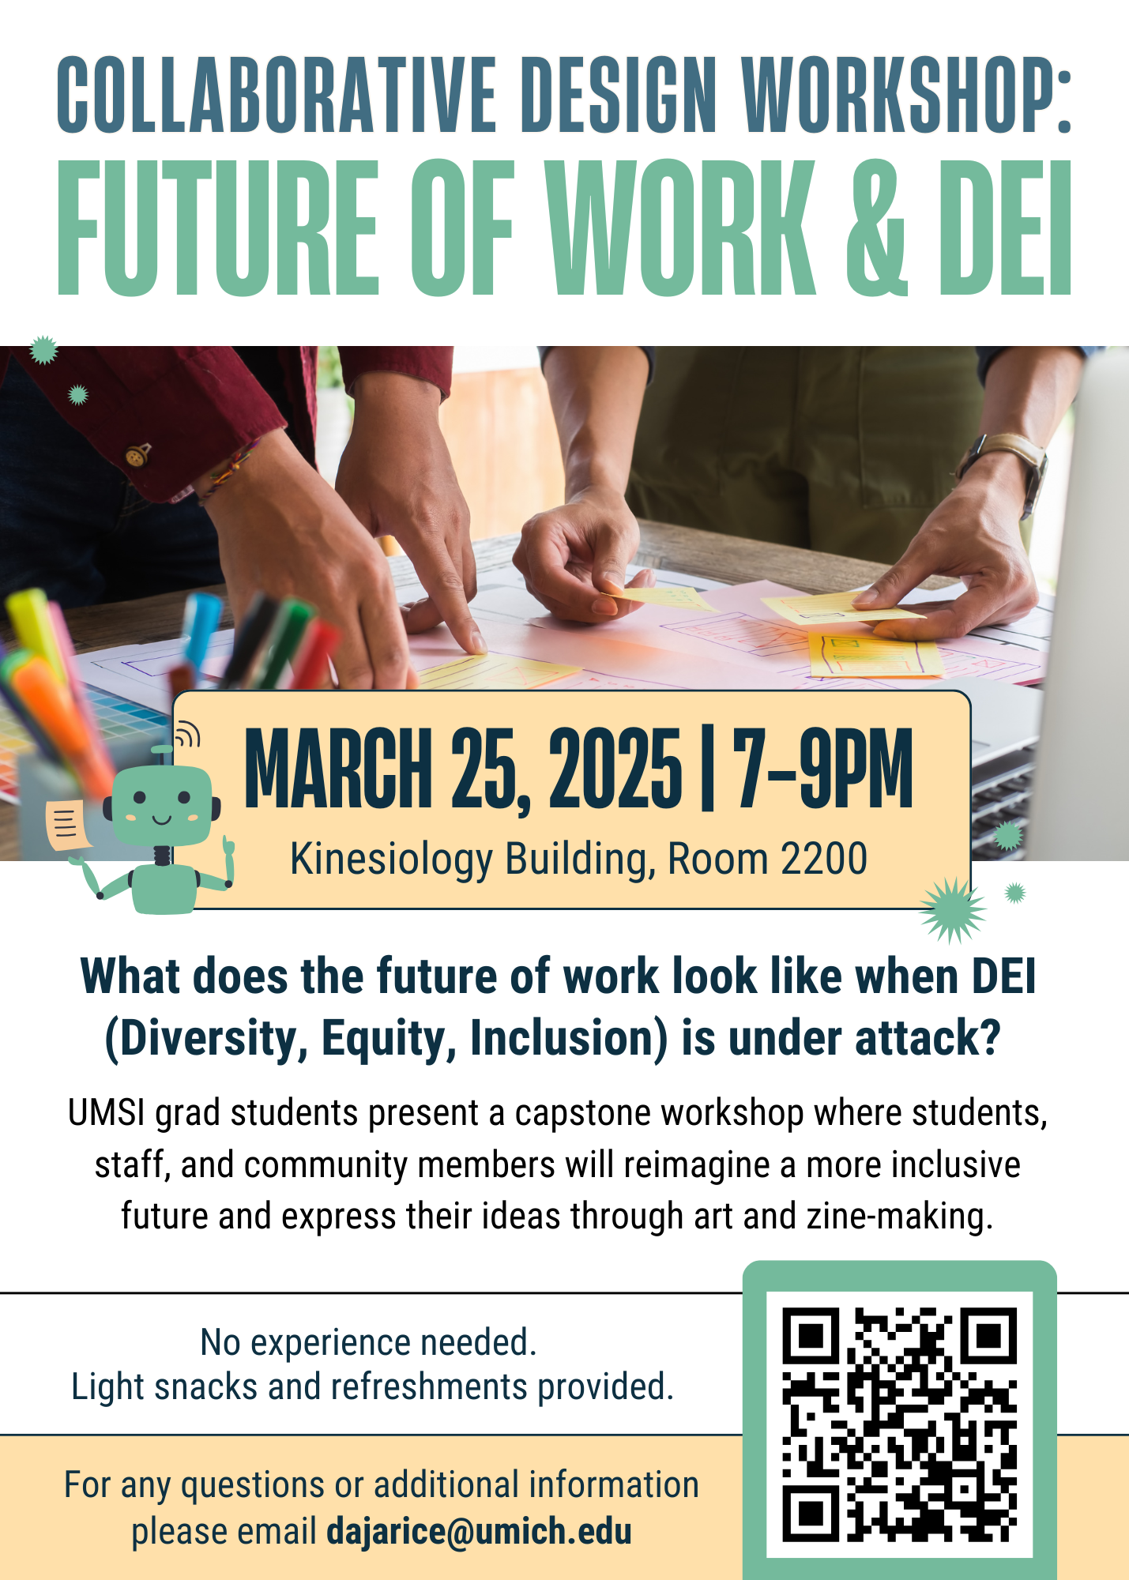(crop this)

UMSI graduate students are presenting **Future of Work & DEI**! Chill with us on **March 25th at 7-9pm** for an evening of art and zine-making as UMSI grad students present an SI 699 capstone workshop imagining a more inclusive future. No prior experience necessary. Light refreshments provided.

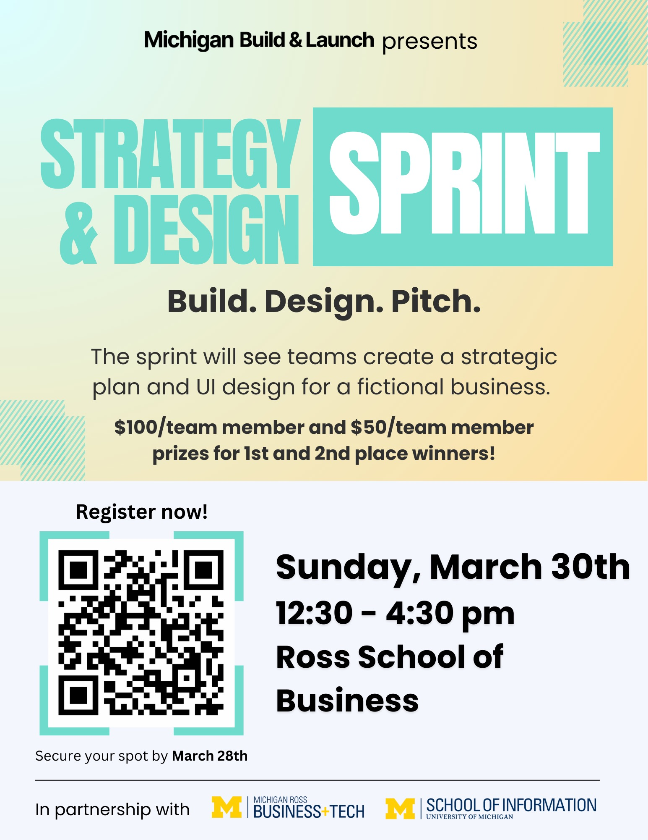

Join Michigan Build & Launch’s **Strategy and Design Sprint Competition** on Sunday, March 30th, from 12:30 - 4:30 PM at the Ross School of Business for a chance to win $100! Teams of 2-5 will ideate and present a strategic plan and UI design for a fictional business to a panel of judges. No prior experience necessary. Register [HERE](https://docs.google.com/forms/d/e/1FAIpQLSf0COe5FYB9Umd-ooPBMg5ena9OeUvMy3v5TZhlz8OJvtU8kw/viewform?usp=header) individually or as a team before Friday, March 28th to secure your spot!

# Game

Guess the app,